**VISVESVARAYA TECHNOLOGICAL UNIVERSITY**

“Jnana Sangama”, Belagavi -590 014, Karnataka.

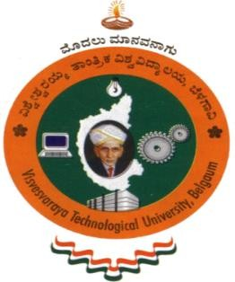

A Technical Seminar Report

On

***“*BLOCKEYE: HUNTING FOR DEFI ATTACKS ON BLOCKCHAIN*”***

Submitted in the partial fulfillment of the requirements for the award of the Degree of

**BACHELOR OF ENGINEERING IN**

**INFORMATION SCIENCE AND ENGINEERING**

*Submitted by*

**KRISHNAM CHATURVEDI (1EW17IS048)**

***Under the Guidance of***

**Mrs. ANJANA H S**

**ASST.PROFESSOR**

**DEPT. OF ISE, EWIT**



**DEPARTMENT OF INFORMATION SCIENCE AND ENGINEERING**

**EAST WEST INSTITUTE OF TECHNOLOGY**

BENGALURU - 560 091

2020-2021

**EAST WEST INSTITUTE OF TECHNOLOGY**

Sy.No.63, Off. Magadi Road, Vishwaneedam Post, Bengaluru - 560 091

(Affiliated To Visvesvaraya Technological University, Belagavi)

**DEPARTMENT OF INFORMATION SCIENCE AND ENGINEERING**



**CERTIFICATE**

This is to certify that the Technical Seminar entitled **“BLOCKEYE: Hunting for DEFI Attacks on Blockchain”** presented by **KRISHNAM CHATURVEDI (1EW17IS048),** Bonafede student of **EAST WEST INSTITUTE OF TECHNOLOGY**, Bengaluru in partial fulfillment for the award of **Bachelor of Engineering** in **Information Science and Engineering** of **Visvesvaraya Technological University**, Belagavi during the year **2020-21**. It is certified that all corrections/suggestions indicated for Technical Seminar have been incorporated in the report. The Technical Seminar has been approved as it satisfies the academic requirements in respect of Technical Seminar prescribed for the said degree.

---------------------------- ---------------------------- ------------------------------

Signature of Guide Signature of HOD Signature of Principal

**Mrs. Anjana H S Dr. Suresh M B Dr. K Channakeshavalu**

Asst. Prof, Dept. of ISE Prof & Head, Dept. of ISE Principal

EWIT, Bengaluru. EWIT, Bengaluru. EWIT, Bengaluru.

**External Viva**

**Name of the Examiners Signature with date**

**1.**

**2.**